Model 1:

1. Imported Train data using the File Import node

1. Partitioned the data using Data Partition node

1. Ran a Neural Network model (Neural Network 1):

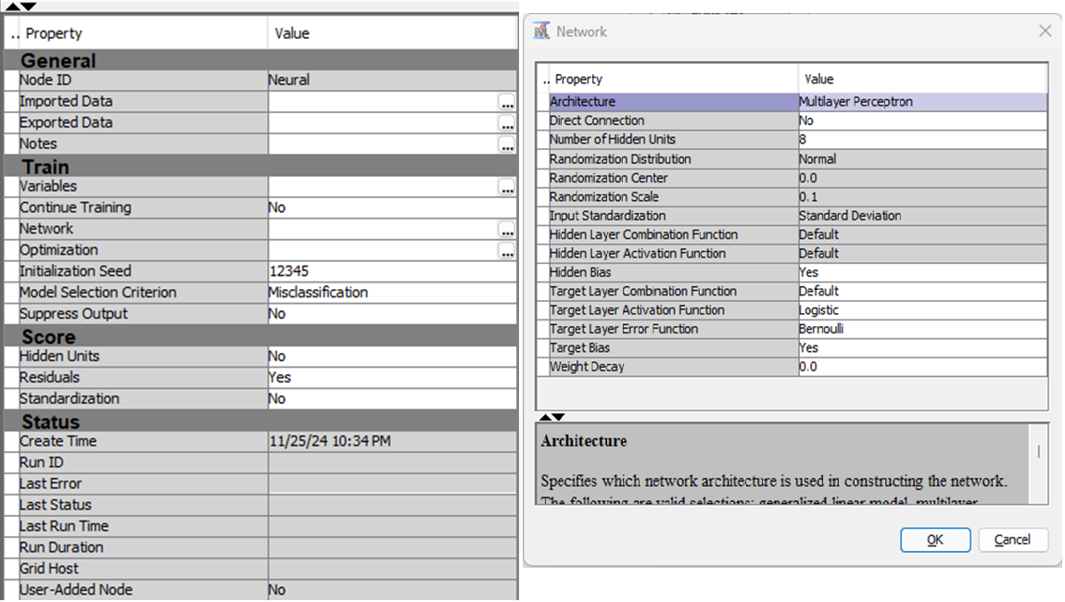

1. Ran another Neural Network model (Neural Network 2):

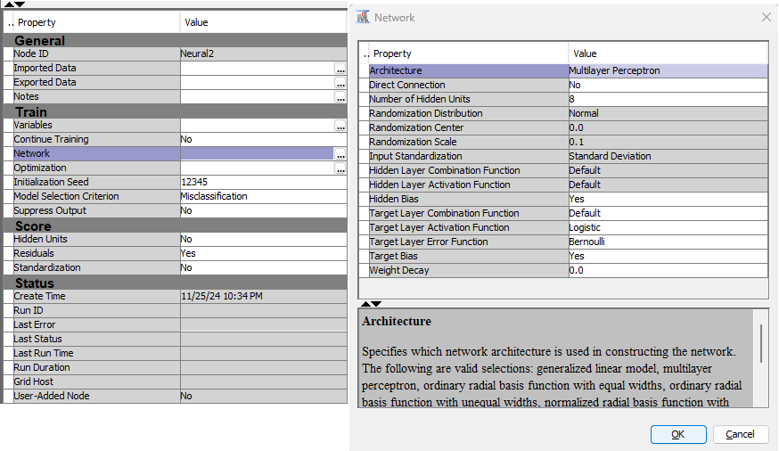

1. Ran a Gradient Boosting model:

1. Ran a Lasso model:

1. Ran a 2nd Degree polynomial Logistic regression model:

1. Ran an Ensemble model:

1. Compared the models using Model Comparison mode:

1. Imported the Test data using File Import node:

1. Used Score node to run the best model from Model Comparison node using the Test data:

1. Used Save Data node to save the prediction output in file:

Model 2:

### **Workflow Description**

1. **Data Preparation**
   1. **File Import (Train):** Training data is imported and processed.
   2. **Data Partition:** Splits the data into training and validation sets.
2. **Model Training**
   1. **Primary Models:** Includes Gradient Boosting, Neural Network, Regression, and LARS.
   2. **Additional Models:** A second set of Neural Network, Gradient Boosting, LARS, and Regression models is introduced.
3. **Ensemble Learning**
   1. **First-Level Ensemble:** Combines predictions from the primary models.
   2. **Second-Level Ensemble:** Aggregates results from the first ensemble and additional models to enhance accuracy.
4. **Model Evaluation**
   1. **Model Comparison Node:** All ensemble and individual model results are evaluated using performance metrics (e.g., ROC).
5. **Scoring and Output**
   1. **Score Node:** Generates predictions using the best model.
   2. **Save Data Node:** Saves the scored output for further use.

